**WIA 1006**

**TUTORIAL 6 Stack**

**Question 1**

The stack method that returns an element from the stack without removing it is ____________.

a. pop

b. push

c. peek

d. spy

ANSWER: peek

**Question 2**

We have three stacks, s1, s2 and s3, that can contain data of type String. Here are their initial contents:



As you can see, initially s2 and s3 are empty. Here is a sequence of operations on the three stacks:

s2.push(s1.pop());

s3.push(s1.pop());

s1.pop();

s1.push(s2.pop());

s2.push(s3.pop());

s2.push(s1.pop());



Draw the contents of the three stacks after the operations are complete.

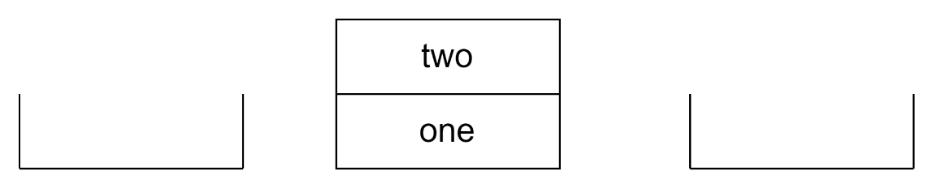

S1 S2 S3

**Question 3:**

Over time, the elements 1, 2, and 3 are pushed onto a stack **in that order**. For each of the following, indicate (yes or no) whether the sequence could be created by popping operations. If yes, list the sequence of push() and pop() operations that produces the sequence. (want what we get)

1. 1-2-3

Yes

pop();

pop();

pop();

push();

push();

push();

**push(1), pop(), push(2), pop(), push(3), pop()**

1. 2-3-1

Yes

pop();

pop();

push();

push();

pop();

push();

**push(1),pop(),push(2), pop(), push(3),pop()**

(c) 3-2-1

Yes

pop();

push();

pop();

push();

pop();

push();

**push(1),pop(),push(2), pop(), push(3), pop()**

(d) 1-3-2

Yes

**push(1),pop(),push(2), push(3), pop(),pop()**

**Question 4:**

Convert the following infix expressions to postfix:

a) a + b * c

b) a * b – c/d

c) a + (b*c + d)/e

a) a b c * +

b) a b * c d / -

c) a b c * d + e / +

**Question 5:**

Write the following expressions in infix form:

a) a b + c *

b) a b c + *

ANSWER:

a) (a + b) * c

b) a * (b + c)

**Question 6:**

Which of the following is an application of stack?

A. finding factorial

B. tower of Hanoi

C. infix to postfix

D. all of the above

ANSWER: All of the above

* Finding factorial: A stack can be used to keep track of the numbers in the factorial calculation.
* Tower of Hanoi: A stack can be used to keep track of the disks during the Tower of Hanoi game.
* Infix to postfix: A stack can be used to convert infix expressions to postfix expressions.